AB 2774 Sample Social Media Posts

IMAGE | POSTS
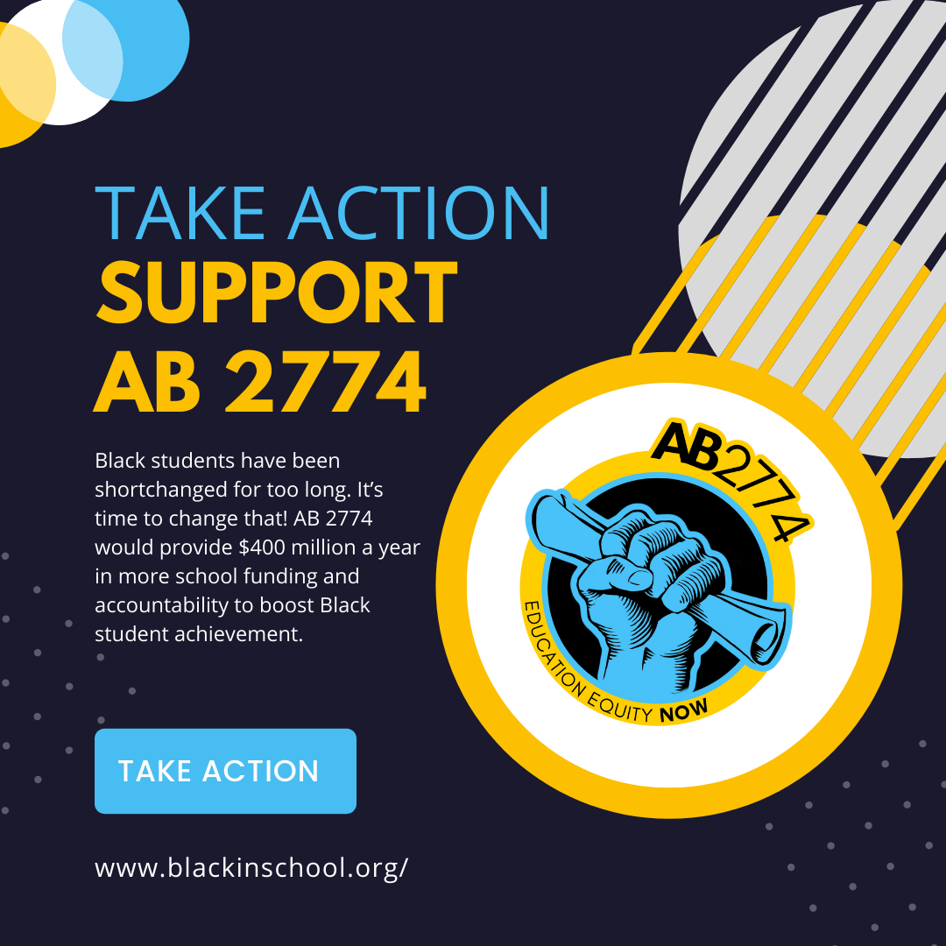 | Take Action and ensure Black students receive the funding they deserve! Currently, there are approximately 80,000 Black students not receiving additional support. Click here to send a letter of support and contact your Senator to pass AB 2774.
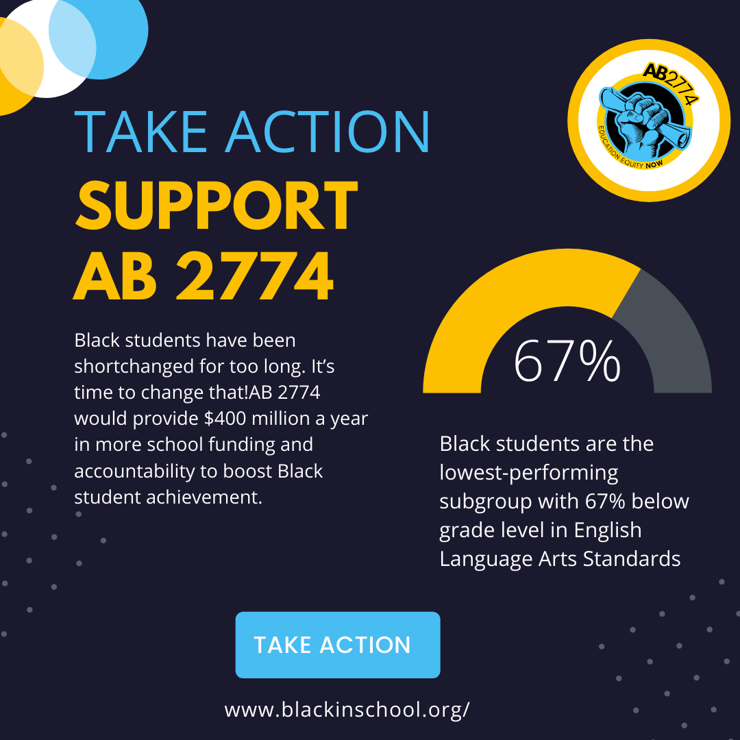 | It’s time Black kids get the resources they deserve! AB 2774 will allocate at least $400 million per year to improve outcomes for historically underserved students. Visit our website to send a letter to the California Senate.
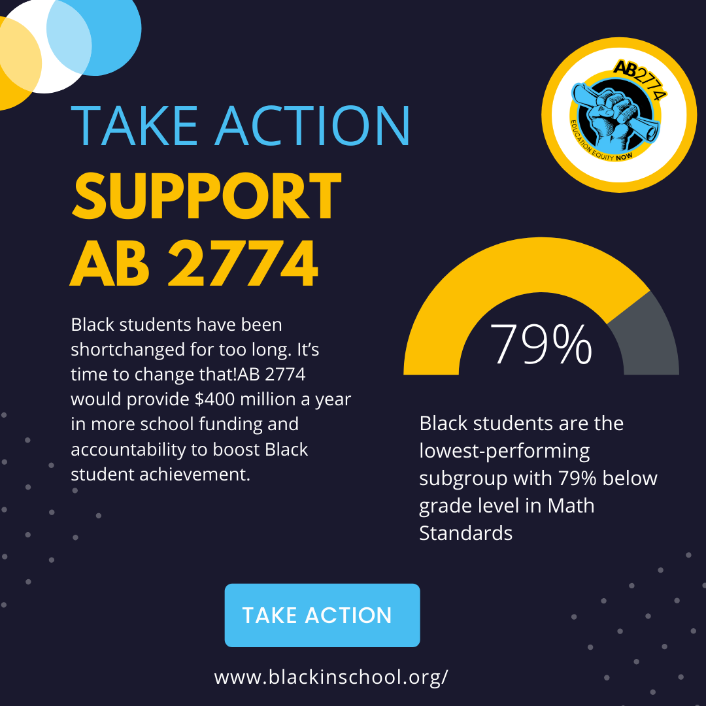 | AB 2774 would create a new supplemental grant category in the Local Control Funding Formula to include the lowest-performing subgroup of students statewide that is not already receiving supplemental state or federal funding. Currently, these are Black students. Click here to send a letter of support and contact the Senate to pass AB 2774.
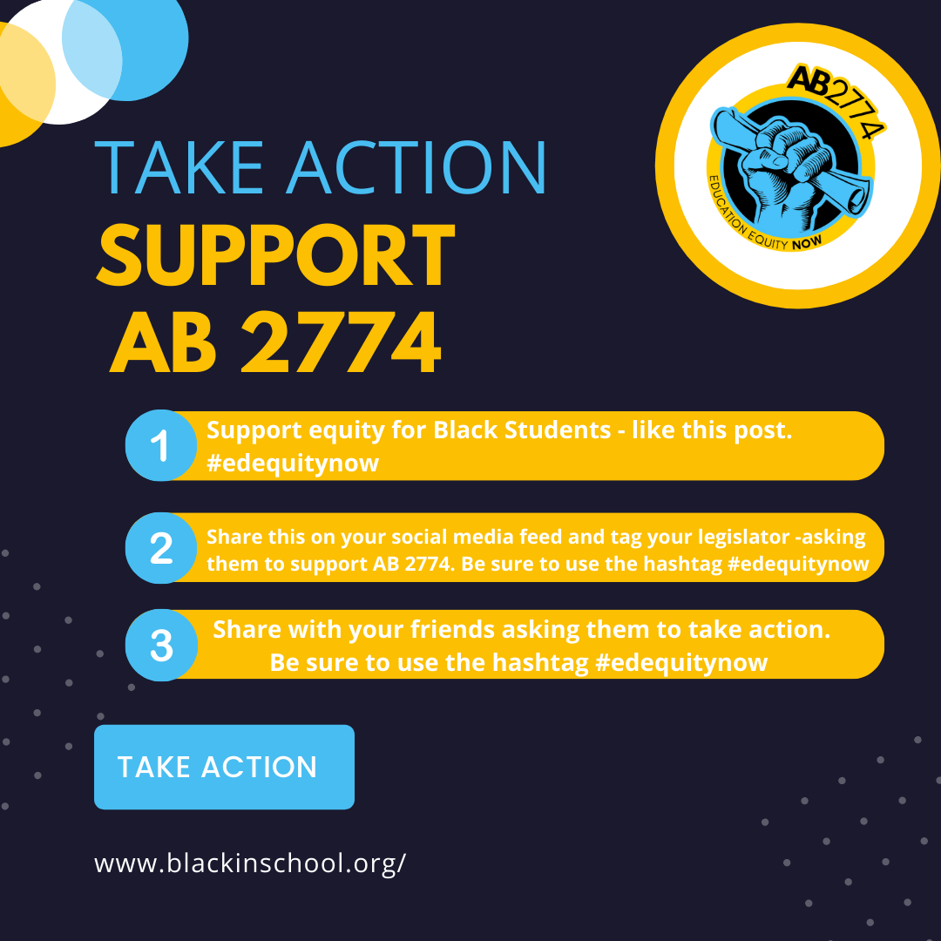 | Black kids have been shortchanged for too long. It’s time to change that! AB 2774 would provide $400 million a year in more school funding and accountability to boost Black student achievement. Click here to send a letter of support and contact the Senate to pass AB 2774.

Twitter Messages

Black kids have been shortchanged for too long. AB 2774 would provide $400 mil a year in more school funding to boost Black student achievement. @Senator NAME - vote yes on AB2774

@SenatorName Vote yes on AB 2774. It’s time Black kids get the resources they deserve! AB 2774 will allocate at least $400 mil per year to improve outcomes for historically underserved students.

